Quantitative Research Methods
Keywords Part 2
Can be used in preparation of topic presentation and in preparation for quizzes

6 Design (Chapter 7)
Internal validity
Necessary prerequisites for establishing cause and effect relationships
Note: when these conditions cannot be met, the Bradford Hill Criteria may be applied
Single group study designs and threats
History, maturation, …., regression to the mean
Multiple group study designs and threats
Same threats, now framed as selection-… threats
Social interaction threats
Design notation
Different types of designs
Random assignment (versus random sampling!)
True experiment / quasi-experiment / non-experiment

7 Experimental Design (Chapter 9)
There is some overlap with the previous chapter, but here we deal with true experiments
Two-group experimental design
Idea of probabilistic (or stochastic) equivalence (by random assignment)
Classifying designs
Signal enhancing versus noise reducing
Factorial designs
Analysis by ANOVA: main effects, interaction effects
Randomized Block design (illustration in session on analysis or wrap up session)
Covariance design
Hybrid designs
Solomon four-group design
Switching replications design

8 Quasi-Experimental Design (Chapter 10)
Definition, how does it differ from true experimental design
Non-equivalent group design
Possible outcomes and their interpretation
Regression-discontinuity design
Logic and interpretation
Other types of quasi-experimental design
Proxy pretest
Separate pre-post samples design
Double-pretest design
Switching replications design

Pattern-matching non-equivalent dependent variables design
Regression point-displacement design

9 Analysis I (Chapter 12)
Conclusion validity: reaching a correct conclusion
Hypothesis testing and statistical inference
Null-hypothesis versus alternative hypothesis
Matrix of what is true and what is concluded
Possible errors: type 1 error (α) and type 2 error (β)
Power (1- β)
Relationship between type 1 and type 2 error
How to improve conclusion validity
Note: important to distinguish statistical significance and practical relevance
Handling of data
Logging/storing data
Checking for accuracy of data/data quality/acceptability of survey (completeness, attentiveness of respondents (e.g. straight-lining), plausibility of response patterns, etc.)
Record keeping (code book, content of variables, how new variables were computed (e.g. sum scores or mean scores), transformations, reversing scores, etc)
When collapsing scores, keep copy of original variable
Data entry (most data is collected/recorded electronically nowadays; if paper & pencil data is to be entered, consider double entry, retain original paper questionnaires)
Missing values
Different types of missing data (to be discussed)
Imputation (replacing missing values)

Descriptive statistics
Discrete distribution (frequency tables; nominal and ordinal scales)
Continuous (at least in principle) distribution (metric variable)
Central tendency
Mean, median, mode – when to use which
Dispersion/variability
Variance and standard deviation; quartiles and interquartile range; range
Measures of association: correlation
Pearson correlation for metric variables
Coefficients for ordinal variables (Spearman, Kendall, gamma coefficient, etc)
Cross-tabulation/Coefficients for nominal-scaled variables (contingency coefficients, phi, etc, see also chi-square)
Graphics/Explorative data analysis
Box-plot
Stem-and-leaf plot (for small samples), note: Figure 12-12 is not a standard stem-and-leaf diagram

Data considered in Trochim (chapter 12, page 269)
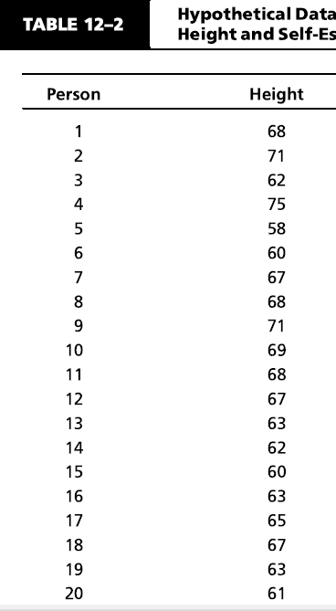

Steam-and-leaf plot in Trochim (chapter 12, page 278)
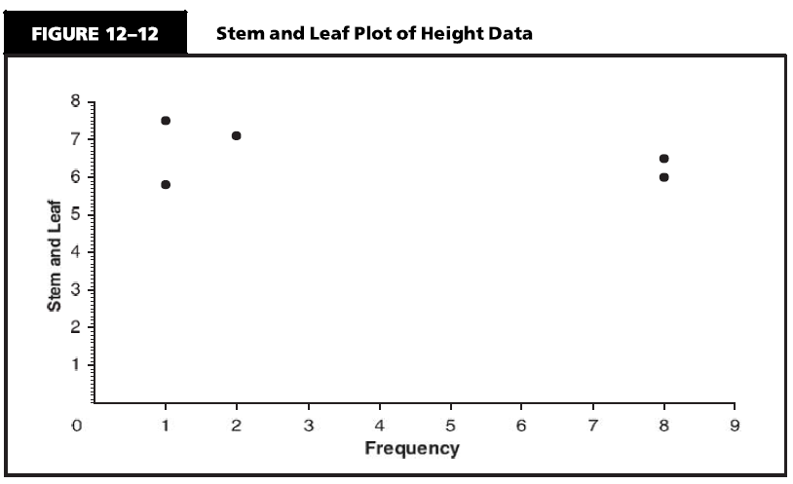
75 -> 1 time
71 -> 2 times in the data
58 -> 1 time in the data (id #5)
60 -> 8 times in the data (however values from 60 to 63)
65 -> 8 times in the data (however values from 65 to 69)
Proper Steam-and-leaf plot from SPSS:
Frequency Stem & Leaf
1,00 5 . 8
8,00 6 . 00122333
8,00 6 . 57778889
2,00 7 . 11
1,00 7 . 5
Stem width: 10
Each leaf: 1 case(s)
Stem to be multiplied by 10, so 6 means 60, leaf of 5 for stem 6 means 65
Trochim’s version conveys the same distribution but does not reveal actual values within the same stem value
Histogram versus bar chart
Anscombe’s quartet
Four small data sets with very different bi-variate distributions (some are similar even in terms of univariate distributions) yield the same summary statistics (mean, variance, regression, correlation)
Illustrates importance of graphical display (scatter gram in this case)

10 Analysis I (Chapter 14 up to page 308)
Inferential statistics
Confidence interval
Effect size (→ relevance)

General linear model
Linear regression

Dummy variables
Definition and use

Analysis of experimental designs
Two groups mean comparison: t-test
More than two groups/factorial designs
Analysis of variance
Use of dummy variables in regression

Randomized block design analysis
Analysis of co-variance
(will be illustrated)

